Strategy Overview





**Global TMI Is Local**

Total Member Involvement (TMI) is a global initiative, but its success depends on the faithful efforts of pastors and lay leaders in local churches. The ***Seventh-day Adventist Church Manual*** (2022) urges every church to **“enlist all members and children”** in **“personal outreach”** (p. 138). It also emphasizes the positive impact on the spiritual life and growth of members when a church devotes its **“first interests and highest energies to involving every member in proclaiming the good news and making disciples”** (p. 135).

**Global TMI Is Active and Ongoing**

The top priority of every church board is to establish **“an active, ongoing discipleship plan”** that includes both **“spiritual nurture and outreach ministries”** (p. 137). Global TMI is more than an invitation to participate in a one-time event. It is the launch of an active and ongoing disciple-making plan that aims to involve every member. Because Jesus likened making disciples to the harvest cycle, Global TMI emphasizes 5 essential ministries that align with the agricultural disciple-making process (prepare, plant, cultivate, harvest, preserve).

**Preliminary Steps**

Before establishing the essential outreach ministries needed to make disciples, pastors and lay leaders should aim to inspire and equip their own members by taking the following steps:

**1. Emphasize Spiritual Revival**

**2. Establish an Interest Review Process**

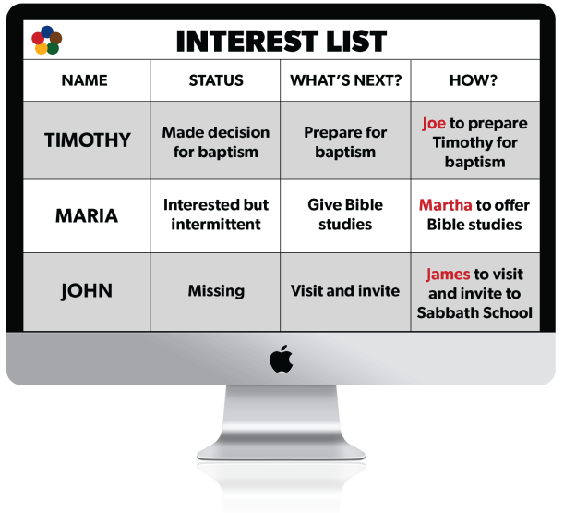

**3. Provide Personal Evangelism Training**

**Christ’s Method Was Personal**

The key to successful evangelism is personal labor. **“This was Christ's method”**(*Christ’s Object Lessons*, p. 229). Ellen White stressed that if we can have only one part done between personal work and more extensive meetings, **”let it be the individual labor”** (*Christian Service*, p. 121). Still, **When both are combined, with the blessing of God, a more perfect and thorough work may be wrought”** (*ibid*.). Therefore, Global TMI combines public and personal evangelism, but in harmony with Christ’s method, infuses every ministry or event with personal evangelistic effort.

**Every Church a Training School**

To involve as many church members as possible in personal evangelism, every pastor and church should provide training and resources that equip individual church members, Sabbath School classes, and other small groups in areas such as:

* Praying for interests
* Befriending and ministering to needs
* Visiting and contacting interests
* Sharing literature and media
* Inviting to Sabbath School, church, and church events
* Inviting to take Bible studies
* Giving Bible studies
* Mentoring and training new members

Ellen White aptly stated, **“Many would be willing to work if they were taught how to begin. They need to be instructed and encouraged. Every church should be a training school for Christian workers”** (*The Ministry of Healing*, p. 149).

**Establish Essential Disciple-Making Ministries**

After taking the preliminary steps of revival and equipping of the members of your church, the next steps in the strategy involve establishing the five areas of essential disciple-making ministries that form the framework of a local church discipleship plan: PREPARE the soil of the heart with Health and Friendship-Building Ministries, PLANT seeds of truth with Literature, Media, and Invitation Ministries, CULTIVATE spiritual interest with Bible Study Ministry, HARVEST decisions for Christ with Evangelistic Reaping Meetings (traditional, seminar, or small group), and PRESERVE the harvest with New Member Discipleship Training.

[Go to Revival Resources](https://www.globaltmi.org/resources/#getting-ready-section)



*“I kept back nothing that was helpful, but proclaimed it to you, and taught you publicly and from house to house”*(Acts 20:20).

*"I am the vine, you are the branches. He who abides in Me, and I in him, bears much fruit; for without Me you can do nothing"*(John 15:5).



*“Nothing is more needed in our work than the practical results of communion with God”*(Gospel Workers, *p. 510*).

*“Through much prayer you must labor for souls, for this is the only method by which you can reach hearts”*(Evangelism, *p. 341*).

*“There is something for everyone to do. Every soul that believes the truth is to stand in his lot and place, saying, 'Here am I; send me.' Isaiah 6:8”*(Christian Service, *p. 10*).

*“The work of God in this earth can never be finished until the men and women comprising our church membership rally to the work and unite their effort with those of ministers and church officers”*(Testimonies for the Church, *vol. 9, p. 116*).

*“Let every church member become a working member, to build up spiritual interests”*(Evangelism, *p. 64*).

*“In the ministry of the word there is too much sermonizing, and too little of real heart-to-heart work. There is need of personal labor for the souls of the lost”*(Christ's Object Lessons, *p. 57*).

*“Christ's method alone will give true success in reaching the people. . . . There is need of coming close to the people by personal effort”*(The Ministry of Healing, *p. 143*).

**Explore the full Global TMI strategy by navigating through the five essential areas of disciple-making.**

* [Overview](https://www.globaltmi.org/strategy/overview/)
* [01. Prepare](https://www.globaltmi.org/strategy/prepare/)
* [02. Plant](https://www.globaltmi.org/strategy/plant/)
* [03. Cultivate](https://www.globaltmi.org/strategy/cultivate/)
* [04. Harvest](https://www.globaltmi.org/strategy/harvest/)
* [05. Preserve](https://www.globaltmi.org/strategy/preserve/)